EXP NO 2:CREATE A SIMPLE CLOUD SOFTWARE APPLICATION FOR CAR BOOKING RESERVATION SYSTEM USING ANY CLOUD SERVICE PROVIDER TO DEMONSTRATE SAAS.

AIM: To design and deploy a cloud-based Car Booking Reservation System using Zoho Creator to demonstrate the Software as a Service (SaaS) model, allowing users to book cars online and administrators to manage bookings through a web browser.

PROCEDURE:
- Open https://creator.zoho.com and log in using your Zoho account.
- Click Create Application → Blank App.
- Enter the application name as Car Booking Reservation System and click Create.
- Create one form named Car Booking Form.
- Configure a workflow to automatically calculate Total Amount = Number of Days × Price per Day.
- Save the form and enable Form Permissions for user access.
- Create a Report from the same form to view booking details.
- Click Access This App → Publish to deploy the application online.

OUTPUT:
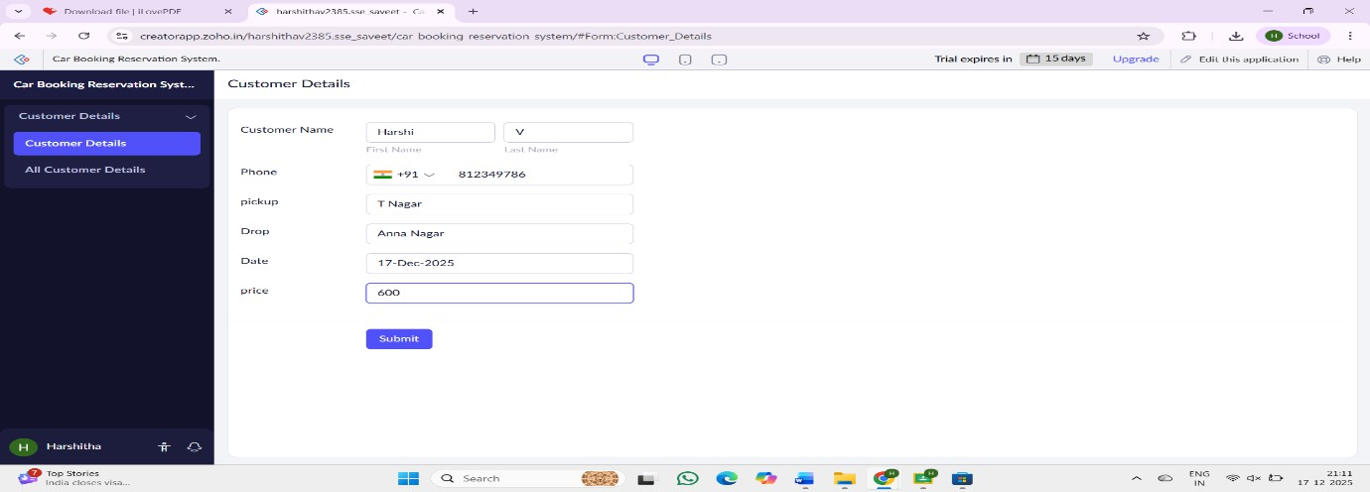

RESULT:
A cloud-based Car Booking Reservation System with a single form was successfully created and deployed using Zoho Creator, demonstrating the SaaS model.

